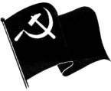
g]kfn sDo'lgi6 kf6L{ -g]skf_
lhNnf sfof{no lrtjg
k|]; lj1lKt
ldlt M @)&^.)(.)^
cfh ldlt @)&^ k'; ^ ut]sf lbg dWojtL{ pkef]Qmf ;ldltsf] ;a} 6f]nsf OsfOsf] e]nfn] ;j{;Ddt cWoIf, pkfWoIf / ;lrj;d]t ;j{;Ddt 5gf]6 u/L d[us'~h dWojtL{ pkef]Qmf ;ldltsf] sfof{nodf k]z ug{ hfFbf /Tggu/ gkf j8f g+= % lgjf;L g]kfnL sfFu|];sf sfo{stf{x? Clif u'?ª, ofbj kf}8]n, k|sfz vqL, ljsf; u'?ª, lji0f' l/dfn, >L tfdfªnufotsf JolQmx?n] g]kfn sDo'lgi6 kf6L{ -g]skf_ lhNnf sld6L ;b:o s=b'uf{k|;fb l3ld/], :yfgLo g]tf s=Zofd b]jsf]6f / s /f]hgfy kf7sdfly n5f/k5f/ / s'6lk6 u/]sf] 36gfk|lt kf6L{sf] uDeL/ Wofg cfs[i6 ePsf] 5 .
dWojtL{ If]qcGtu{t d[us'~h dWojtL{ jg pkef]Qmf ;ldltsf] OsfOdf ;j{;Ddt cWoIf, pkfWoIf / ;lrj 5gf]6 ePsf] cj:yfdf pkef]Qmfx?sf] clwsf/dfly x:tIf]k ug]{ lgotn] sfof{no xftfleq} cfqmd0f x'g' cWoIf lgGbgLo sfo{ xf] . /fhgLlts k"jf{u|xsf cfwf/df g]kfnL sf+u|]; k6sk6s g]skfsf g]tf sfo{stf{x?dfly lx+;fTds cfqmd0fdf plqFb} cfPsf] ;j{ljlbt} 5 . sfg'g xftdf lnO{ ;f+3flts cfqmd0f ug{] sf+u|];sf] rl/q g} ag]sf] 5 . g]kfn sDo'lgi6 kf6L{ o:tf] sfo{sf] 3f]/ lj/f]w / eT;{gf ub{5 / 36gfdf ;+nUg ck/fwLx?nfO{ t'?Gt kqmfp u/L ;To tYosf] cfwf/df sfg'gadf]lhd sf/afxL ug{ tyf k'/fgf] d]l8sn sn]h e/tk'/df uDeL/ cj:yfdf cfO{;Lo'df pkrf/ eO/x]sf 3fOt]x?sf] lgMz'Ns pkrf/sf] Joj:yf ldnfpg :yfgLo k|zf;g;Fu hf]8bf/ dfu ub{5 .
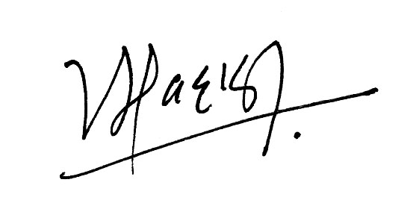

-s[i0feQm kf]v/]n_ -odaxfb'/ kl/of/ …OGb|hLtÚ_
;lrj cWoIf

